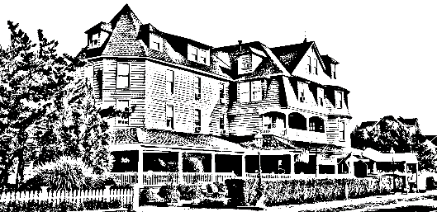

*The Grenville*

*Hotel & Restaurant*

Brunch with The Bunny

Assorted Breakfast Breads and Pastries

Omelet Station with traditional fixing

Pancakes

Stuffed French Toast/ Waffles

Bacon/ Sausage

Chicken Fingers and French Fries

Macaroni and Cheese

Roasted Potatoes/ Sautéed Vegetables

Chicken Francaise

Swedish Meatballs

Penne Vodka

Seafood Ensemble: Sea bass, Mussels, Clams, Shrimp

Caesar Salad/ Mixed Green Salad

Assorted Desserts and Fruit

Beverages included



$399.99 per adult & $29.99 per child

*\*Tax and gratuity not included\**

*Please let your server know if there are any food allergies or if you do not prefer one of the entrees included in the platter.*